South Australia
Adelaide Festival Theatre Act 1964
An Act to provide for the erection in the City of Adelaide of a Festival Theatre and for the financing thereof and matters connected therewith and incidental thereto and for other purposes.

Contents
Part 1—Preliminary
1 Short title
2 Interpretation
Part 2—Festival Theatre
3 Power to construct Festival Hall
4 Vesting and control of Festival Hall
Part 3—Financial
5 Financial provision
6 The Carclew property etc
7 Further financial provision
7A Financial arrangements consequential on the vesting of the Theatre in the Adelaide Festival Centre Trust
7B Payment by Treasurer
7C Discharge of further liability of council etc
9 Payments by the Treasurer
10 Arbitration
Part 4—Vesting of land
11 Definition
12 Partial cancellation of land grant and divesting etc of certain land
13 City Public Baths
14 Vesting of certain land in The Corporation of the City of Adelaide
15 Vesting of certain lands in the Crown
16 Duty of Registrar-General
Part 5—Miscellaneous
17 The Adelaide Festival Theatre Appeal Fund etc
Schedule
Legislative history

The Parliament of South Australia enacts as follows:
Part 1—Preliminary
1—Short title
This Act may be cited as the Adelaide Festival Theatre Act 1964.
2—Interpretation
In this Act, unless the context otherwise requires—
the council means the council of The Corporation of the City of Adelaide;
the 1970 amending Act means The Festival Hall (City of Adelaide) Act Amendment Act 1970;
the Festival Theatre means the Festival Theatre, buildings, furniture, instruments, fittings and equipment, works and conveniences authorised by this Act to be constructed and provided;
the fund means the "Adelaide Festival Theatre Appeal Fund" established by the Lord Mayor of the City of Adelaide;
the trustees means the trustees of the fund appointed under section 17 of this Act;
the vesting day means the vesting day fixed pursuant to section 28A of the Adelaide Festival Centre Trust Act 1971.

Part 2—Festival Theatre
3—Power to construct Festival Hall
(1) The council may, subject to this Act, construct and provide on land within the City of Adelaide vested in, purchased or otherwise acquired by the council, a Festival Theatre and buildings to be used in connection therewith and may provide the furniture, instruments, fittings and equipment thereof or therefor and carry out and construct all works and conveniences incidental to or necessary for any of the foregoing.
(2) The Festival Theatre shall be deemed to be a permanent work or undertaking for the purposes of the Local Government Act 1934.
(3) The Festival Theatre shall be constructed and provided in accordance with designs approved by the Minister. Such designs shall set forth and contain such particulars as the Minister may require.
(4) In addition to any other powers to expend its revenue the council may expend its revenue in contributing towards the cost of construction provision and maintenance of the Festival Theatre where that cost was incurred before the vesting day.
(5) In addition to its other borrowing powers, the council may, from time to time, without further or other authority or consent than this section, borrow, on the security of the general rates, such amounts of money not exceeding $1 800 000 as may be necessary to enable it to contribute towards the cost of the construction and provision of the Festival Theatre in accordance with the provisions of this Act.
4—Vesting and control of Festival Hall
Until the vesting day, the Festival Theatre shall remain vested in the council which shall have the care, control and management thereof and notwithstanding any other Act the council may do all things necessary for and incidental and ancillary to such care, control and management.

Part 3—Financial
5—Financial provision
(1) The Treasurer may pay to the council an amount not exceeding £100 000 for the purpose of assisting the council to purchase or acquire land with or without buildings to be used as a site for the Festival Hall. Such amount may be paid so soon after the council has decided upon the site as the Treasurer shall approve.
(2) So much of the cost of the construction and provision of the Festival Hall as does not exceed the sum of £1 000 000 shall be borne as to two-fifths thereof by the Government of the State and as to the remaining three-fifths thereof by the council. If the said cost exceeds the sum of £1 000 000, the excess shall be borne wholly by the council.
(3) Four-fifths of so much of the said cost as does not exceed the sum of £1 000 000 shall in the first place be met by payments by the Treasurer to the council of such amounts as the Treasurer from time to time approves.
(4) As each such payment is made by the Treasurer the council shall become liable to repay to the Treasurer one half of the amount thereof. In respect of the capital indebtedness for the time being remaining outstanding the council shall be liable to pay to the Treasurer interest at the rate of £4 10s. per centum per annum. Such capital indebtedness and interest shall be repaid in equal annual instalments beginning on such date after the thirtieth day of June in the year in which the construction and provision of the said Festival Hall, buildings, furniture, fittings and equipment are completed as the Treasurer shall determine, so that the whole liability shall be discharged over the period of thirty years next after the said thirtieth day of June. The amount of each such instalment and the time and manner of its payment shall, subject to this Act, be determined by the Treasurer.
(5) This Act shall be sufficient authority, without further appropriation, for the payment by the Treasurer of any amount in pursuance of subsection (1) of this section. Any other payments by the Treasurer authorised by this section shall be paid out of monies appropriated by Parliament for the purpose.
6—The Carclew property etc
(1) In this section—
current expenditure means the net amounts expended by the council from time to time for the purposes of or connected with—
(a) the sale of or other dealing with the whole or any portion of the Carclew property; and
(b) the holding and maintaining of the whole or any portion of the Carclew property during the period elapsing between the commencement of the 1970 amending Act and the day of that sale or dealing;
the Carclew expenditure means the net total amount expended by the council before the commencement of the 1970 amending Act on and in relation to the Carclew property in pursuance of the powers conferred on it by section 3 of this Act as then in force including all amounts paid by the council in pursuance of those powers by way of rates and taxes in respect of the whole or any portion of the Carclew property and includes an amount of $7 640 paid by the Treasurer to the council in respect of an investigation and report by Bolt, Beranek and Newman Inc. of New York but does not include any current expenditure;
the Carclew property means those lands situated in the City of Adelaide known as town acres numbers 749 and 750 together with all buildings and structures thereon and includes any property acquired by the council in pursuance of the powers conferred on it by section 3 of this Act as in force before the commencement of the 1970 amending Act for the purposes of or connected with the construction and provision of a Festival Hall on those lands;
the Government's contribution means the total of the amounts paid or borne by the Treasurer pursuant to subsection (1) or (2) of section 5 of this Act and the amount of $7 640 paid by the Treasurer to the council which is included in the Carclew expenditure.
(2) After the commencement of the 1970 amending Act—
(a) no further moneys shall be paid by the Treasurer to the council pursuant to section 5 of this Act; and
(b) that section shall apply and have effect to and in relation to the repayment of the amounts paid by the Treasurer pursuant to subsection (3) thereof as if the construction and provision of the Festival Hall, buildings, furniture, fittings and equipment referred to in subsection (4) thereof had been completed on the day on which the 1970 amending Act commenced.
(3) Notwithstanding any other Act, the council may, with the consent of the Treasurer, sell or otherwise deal with the whole or any portion of the Carclew property and, shall deduct from the proceeds of any such sale or dealing such portion of the current expenditure as, in the opinion of the council, is attributable to such sale or dealing.
(4) Out of the balance of the proceeds of any sale or dealing referred to in subsection (3) of this section after the deduction provided for in that subsection is made the council shall so often as the Treasurer requires pay to the Treasurer an amount which bears to the balance the same relationship as the Government's contribution bears to the Carclew expenditure and the council may retain the unpaid amount of each such balance for its own purposes.
7—Further financial provision
(1) Subject to this section, the Treasurer may pay to the council an amount with any amount so paid pursuant to this section as in force before the commencement of the Adelaide Festival Theatre Act Amendment Act 1973 not exceeding, in the aggregate, $4 900 000 for the purposes of assisting the council to construct and provide a Festival Theatre.
(3) In calculating the amount expended by the council for the purposes of this section no regard shall be had to—
(a) the Carclew expenditure as defined for the purposes of section 6 of this Act; or
(b) any expenditure by the council of moneys paid to the council by the trustees pursuant to subsection (4) of section 17 of this Act that exceeds $100 000.
(4) If the Treasurer is satisfied that the amount expended by the council in the exercise of the powers conferred on it by section 3 of this Act exceeds $7 000 000 as a consequence of an alteration of or addition to the Festival Theatre approved of by the Treasurer the Treasurer may in addition to the amounts authorised by this section to be paid to the council pay to the council an amount equal to the cost to the council of those alterations or additions.
7A—Financial arrangements consequential on the vesting of the Theatre in the Adelaide Festival Centre Trust
(1) On and after the vesting day no further moneys shall be payable by the Treasurer to the council pursuant to section 7 of this Act except any such moneys as are required to be so paid by the Treasurer to satisfy any liability incurred by the Treasurer pursuant to that section before the vesting day.
(2) Nothing in subsection (1) of this section shall affect any liability of the council—
(a) to make the payments to the Treasurer as are required by subsection (4) of section 5 of this Act as modified by paragraph (a) of subsection (2) of section 6 of this Act; and
(b) to make payment to the Treasurer as required by subsection (4) of section 6 of this Act.
7B—Payment by Treasurer
The Treasurer may pay to A.V. Jennings Industries (Australia) Limited, in this section referred to as the Company, an amount not exceeding $42 840 in accordance with an arrangement entered into by the Treasurer and the Company with respect to certain expenditure incurred by the Company in relation to overtime payments in connection with the construction of the Festival Theatre.
7C—Discharge of further liability of council etc
(1) On and from the commencement of the Adelaide Festival Theatre Act Amendment Act 1974—
(a) the council is by force of this section freed and discharged from any liability to make any further payments to the Treasurer as are required by subsection (4) of section 5 of this Act as modified by subsection (2) of section 6 of this Act; and
(b) the Treasurer shall reimburse to the council periodically out of the General Revenue of the State (which is hereby to the necessary extent appropriated accordingly) any amount expended or set aside on or after the first day of July, 1974, by the council in providing for the repayment of principal and interest in respect of any moneys borrowed by the council for the purposes of section 3 of this Act.
(2) Nothing in subsection (1) of this section shall affect or limit the obligation of the council to make payment to the Treasurer of any amount required to be paid pursuant to subsection (4) of section 6 of this Act.
9—Payments by the Treasurer
All payments by the Treasurer authorised by this Act, as in force after the commencement of the 1970 amending Act shall be paid out of moneys which have been appropriated to a deposit account at the Treasury for the purpose prior to the commencement of the 1970 amending Act, or which may be subsequently appropriated by Parliament for the purpose.
10—Arbitration
(1) If any dispute arises between the Treasurer and the council in or in relation to any money payable pursuant to this Act by the Treasurer to the council that dispute shall be resolved by arbitration.
(2) The Arbitration Act 1891 shall apply to and in relation to the dispute referred to in subsection (1) of this section as if in relation to that dispute the Treasurer and the council were parties to a submission as defined in that Act.

Part 4—Vesting of land
11—Definition
In this Part—
(a) the railway land means the land described in the Schedule to Act No. 126 of 1878 being an Act intituled An Act to authorise the Commissioner of Railways to take possession of portion of the Adelaide Park Lands, and for other purposes; and
(b) a reference—
(i) to section 654 shall be read as a reference to the land in the hundred of Adelaide delineated on the plan in the Schedule to this Act bounded by a line joining the points marked C, D, E, F and C on that plan; and
(ii) to section 655 shall be read as a reference to the land in the hundred of Adelaide delineated on the plan in the Schedule to this Act bounded by a line joining the points marked B, C, F, G, H and B on that plan; and
(iii) to section 656 shall be read as a reference to the land in the hundred of Adelaide delineated on the plan in the Schedule to this Act bounded by a line joining the points marked A, B, H, J, K, L, M and A on that plan.
12—Partial cancellation of land grant and divesting etc of certain land
(1) Land Grant Register Book volume 756 folio 114, except in so far as it relates to lands which lie outside section 654, section 655 and section 656, is by operation of this section cancelled and the land in respect of which that land grant is so cancelled shall on and after the commencement of the 1970 amending Act cease to be vested in the South Australian Railways Commissioner as provided in the grant and shall revest in the Crown freed and discharged from any trust, estate, right, title, interest, claim or demand of any description whatsoever.
(2) On and after the commencement of the 1970 amending Act, the land vested in the South Australian Railways Commissioner for an estate of fee simple pursuant to section 3 of the Adelaide Park Lands Act 1928 shall cease to be so vested.
13—City Public Baths
On and after the commencement of the 1970 amending Act the land on the western side of King William Road appropriated as City Public Baths and containing one acre and a half or thereabouts and referred to in section 368 of The Municipal Corporation Act 1890 shall cease to be so appropriated and so much of that land as does not lie within section 654 shall revest in the Crown freed and discharged from any trust, estate, right, title, interest, claim or demand of any description whatsoever.
14—Vesting of certain land in The Corporation of the City of Adelaide
On and after the commencement of the 1970 amending Act section 654 shall vest in The Corporation of the City of Adelaide for an estate in fee simple freed and discharged from any trust, estate, right, title, interest, claim or demand of any description whatsoever.
15—Vesting of certain lands in the Crown
(1) On and after the commencement of the 1970 amending Act so much of the railway land comprised in section 655 and section 656 as was immediately before that commencement vested in the South Australian Railways Commissioner for any purpose shall cease to be so vested.
(2) On and after the commencement of the 1970 amending Act section 655 and section 656 shall revest in the Crown freed and discharged from any trust, estate, right, title, interest, claim or demand of any description whatsoever.
(3) On and after the commencement of the 1970 amending Act and notwithstanding anything in any Act—
(a) section 655 and section 656; and
(b) the land revested in the Crown pursuant to section 13 of this Act,
shall not be under the care, control and management of the council.
16—Duty of Registrar-General
(1) The Registrar-General shall upon the application of—
(a) the council; or
(b) the South Australian Railways Commissioner; or
(c) the Minister,
as the case requires, upon being furnished with such information as he considers necessary, cause to be made such entries and endorsements in any register book or other record in his custody and on any document of title and cause to be issued such certificates of title as he considers appropriate for giving full effect to this Act without being obliged to make any further investigation of title or to make any public advertisement.
(2) In this section—
the Registrar-General means the person for the time being holding the office of Registrar-General under the Real Property Act 1886 or the Registrar-General of Deeds under the Registration of Deeds Act 1935.

Part 5—Miscellaneous
17—The Adelaide Festival Theatre Appeal Fund etc
(1) There shall be two trustees of the fund—
(a) one of whom shall be appointed by the Lord Mayor of the City of Adelaide; and
(b) one of whom shall be appointed by the Treasurer.
(2) A person who before the commencement of the 1970 amending Act had been—
(a) appointed as a trustee of the fund by the Lord Mayor of the City of Adelaide and who was immediately before that commencement in office as such a trustee; or
(b) appointed as a trustee of the fund by the Treasurer and who was immediately before that commencement in office as such a trustee,
shall for the purposes of this Act be deemed to have been appointed a trustee of the fund by the Lord Mayor or the Treasurer, as the case may be, pursuant to subsection (1) of this section.
(3) The Trustees shall—
(a) receive donations to the fund; and
(b) deposit those donations in an ADI; and
(c) place any moneys standing to the credit of the fund and not immediately required on deposit on advantageous terms; and
(d) render a true account of moneys received by and paid from the fund whenever required by the Treasurer and the Lord Mayor of the City of Adelaide.
(4) The trustees shall—
(a) pay out of the fund to the council a sum of $100 000 to be applied by the council in the exercise of the powers conferred on it by section 3 of this Act; and
(b) at the request of the council pay out of the fund to the council from the balance remaining after the payment referred to in paragraph (a) of this subsection has been made such amounts as the council may from time to time require for the purchase or acquisition by the council of works of art for or in connection with the Festival Theatre,
and the receipt of the council for any moneys paid by the trustees pursuant to this subsection shall be a good and sufficient discharge to the trustees of their duty under this section and the trustees shall not be obliged to satisfy themselves as to the application of any moneys so paid.
(4a) As soon as practicable after the vesting day the trustees shall pay to the Adelaide Festival Centre Trust, established by the Adelaide Festival Centre Trust Act 1971, the balance, if any, of the moneys standing to the credit of the fund on that day and the receipt of the Trust for any moneys so paid shall be a good and sufficient discharge to the trustees.
(4b) On and from the vesting day all works of art, purchased or acquired by the council out of moneys provided from the fund, shall vest in and belong to the Adelaide Festival Centre Trust.
(4c) All moneys received by the Adelaide Festival Centre Trust from the trustees of the fund pursuant to subsection (4a) of this section, shall, by force of this subsection, pass to the Trust freed from any trust and shall be used and applied by the Trust for the purchase or acquisition of works of art for or in connection with the Festival Theatre or for any purpose ancillary to that purchase or acquisition.
(5) No action or proceeding shall lie against the trustees or any one of them for any act or thing done by the trustees or any one of them in the exercise or purported exercise of the powers and functions conferred on them by this section.

Schedule
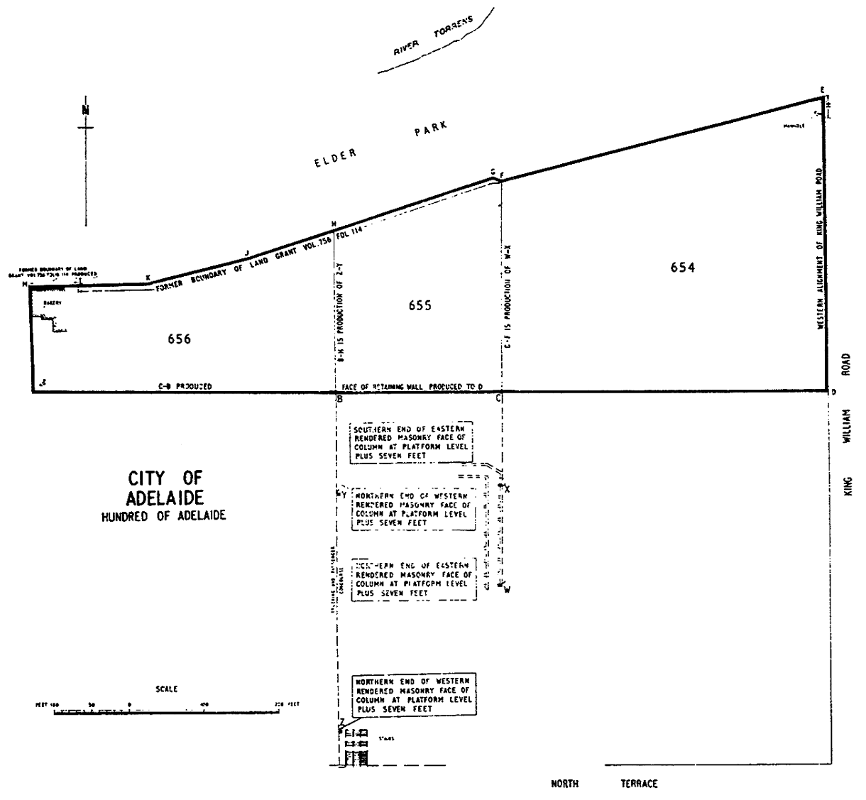

Legislative history
Notes
• For further information relating to the Act and subordinate legislation made under the Act see the Index of South Australian Statutes or www.legislation.sa.gov.au.
Formerly
Festival Hall (City of Adelaide) Act 1964
Principal Act and amendments
New entries appear in bold.
Year | No | Title | Assent | Commencement
1964 | 45 | Adelaide Festival Theatre Act 1964 | 30.10.1964 | 30.10.1964
1970 | 45 | The Festival Hall (City of Adelaide) Act Amendment Act 1970 | 10.12.1970 | 10.12.1970
1973 | 66 | Adelaide Festival Theatre Act Amendment Act 1973 | 6.12.1973 | 13.12.1973 (Gazette 13.12.1973 p3266)
1974 | 99 | Adelaide Festival Theatre Act Amendment Act 1974 | 5.12.1974 | 5.12.1974
1975 | 108 | Adelaide Festival Theatre Act Amendment Act 1975 | 20.11.1975 | 20.11.1975
1999 | 33 | Financial Sector Reform (South Australia) Act 1999 | 17.6.1999 | Sch (item 3)—1.7.1999 being the date specified under s 3(16) of the Financial Sector Reform (Amendments and Transitional Provisions) Act (No. 1) 1999 of the Commonwealth as the transfer date for the purposes of that Act: s 2(2)
Provisions amended since 3 February 1976
• Legislative history prior to 3 February 1976 appears in marginal notes and footnotes included in the consolidation of this Act contained in Volume 1 of The Public General Acts of South Australia 1837-1975 at page 96.
New entries appear in bold.
Entries that relate to provisions that have been deleted appear in italics.
Provision | How varied | Commencement
Pt 1
s 1A | omitted under Legislation Revision and Publication Act
Pt 5
s 17
s 17(3) | amended by 33/1999 Sch (item 3) | 1.7.1999

